**IMPORT PAYROLL**

**INTO JOURNAL ENTRIES**

The payroll entries must be saved as the filename (gltrn-ASS.txt) and use the following format.

The file must be saved under your RCODE directory.

Account#(space)Amount

(hit enter after each line) including the last line.

For example:

1000 -100.00

1010 100.00

1020 -500.00

1030 500.00

The NK1 parameter called PAYVEND must be set to WESTIND.

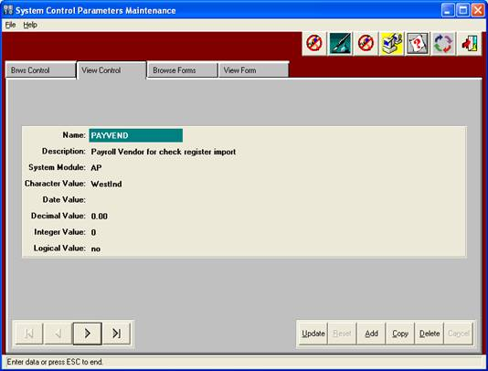

Then run GU4 with the posting date desired and it will import the transactions into GU1(Journal Entries) for you to make any changes and post.